1. Double-click the Auto_activate.exe program, and enter the COM port and Bin file name in the program window, as shown in the following figure, COM port and Bin file need to be separated by a space.

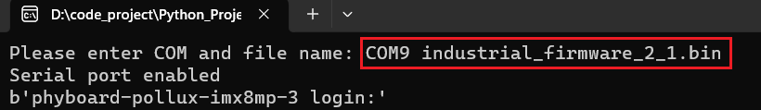

2. After entering the COM port and Bin file name, press Enter on the keyboard. Then you need to restart the SBC board.

(At this time, the window will print a board debugging data every 0.2 seconds - this is not important)

3.Observe the program window until "Start complete" is printed on the program window, indicating that the program has started.

